Outil PPP



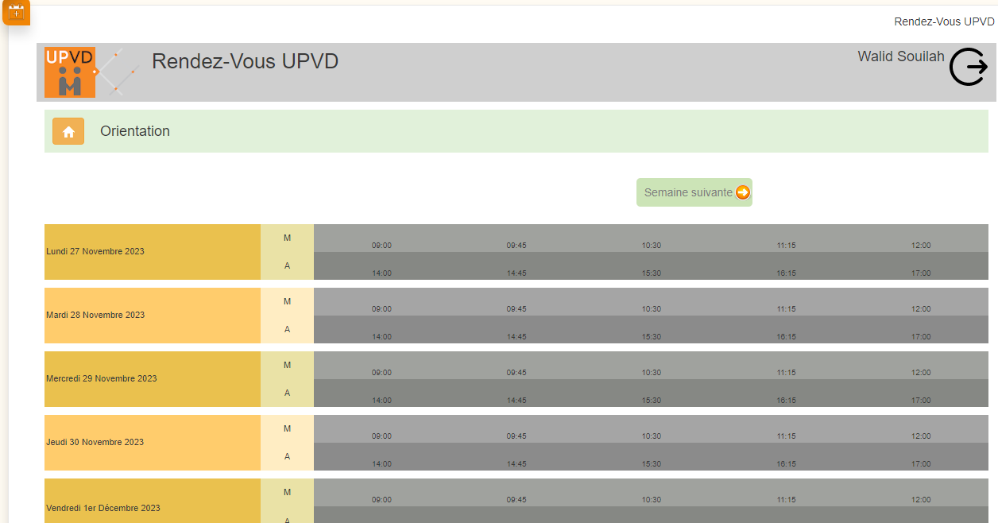

www.shopify.com
www.wizishop.fr
www.ionos.fr
fr.squarespace.com
www.webador.fr


-Pixabay
-Flickr

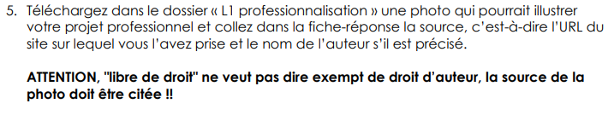


https://cdn.pixabay.com/photo/2017/03/13/17/26/ecommerce-2140604_1280.jpg



